

American International University- Bangladesh

CSC 3222: Web Technologies

CO1.1 and CO2.1 Evaluation

Project Report

Summer 20-21

Project Title: Vital Infusion - HOUSE AND MEDICAL SERVICE MANAGEMENT.

Section: E

|  |  |
| --- | --- |
| Student Name | Student Id |
| Nafinur Leo | 20-42195-1 |
| Tanjim Mahmud Rakin | 19-41424-3 |
| MD Ashraful Amin Sakib | 20-42940-1 |
| Mabin Noor Rashid | 17-35941-3 |

**Vital Infusion - HOUSE AND MEDICAL SERVICE MANAGEMENT**

Introduction:

In this busy era, we always look for a helping hand for our household chores. Sometimes, it becomes essential to find a helping hand. Same for medical services. So, we decided to work on these, so that users can find desired household help and required medical service at the same place.

Background Study

Our project idea came from sheba.xyz, It is a huge website where people can find household helpers based on the categories. The users can search based on their area and many others criteria. We wanted to do the similar kind of project for our country but adding some additional services. Like, medical services. We wanted to build something from where user can find the two of the most important services from a same place, household and medical services. Like, if a user wants book and ambulance, he can do that also if the user wants a hire a driver for his, he can also do that.

Requirement Analysis:

1. User Category:

There are 4-types of Users here. They are:

* Admin
* User
* Service Seller
* Vendor

1. Feature List:

In this project the Admin has the following features:

* They can login to the system
* They can create account to the system
* They can update account information to the system
* They can view their account information from the system

In this project the User has the following features:

* They can login to the system
* They can create account to the system
* They can update account information to the system
* They can view their account information from the system

In this project the Service Seller has the following features:

* They can create account to the system
* They can login to the system
* They can view their account information from the system
* They can advertise to the system

In this project the Vendor has the following features:

* They can create account to the system
* They can login to the system
* They can view their account information from the system
* They can update account information

Design:

Entity diagram:

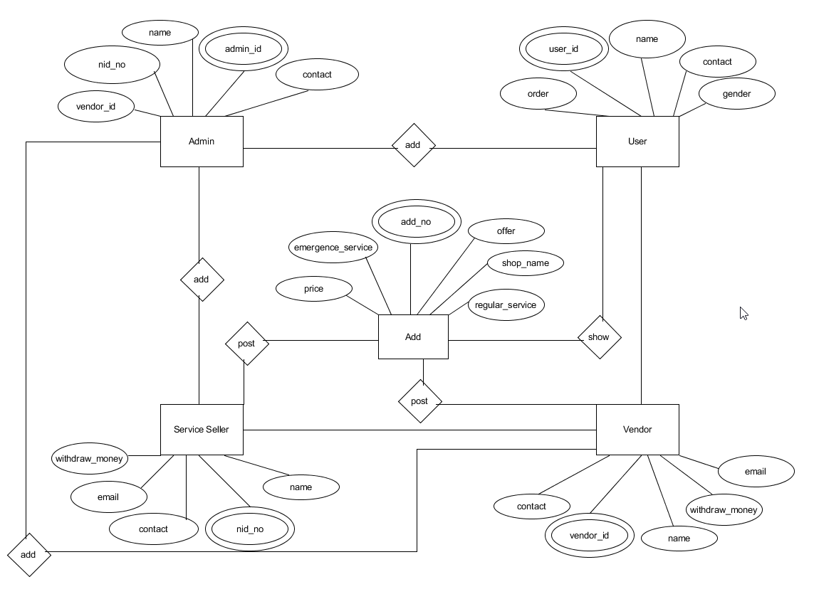

Tools Used:

To develop this project, we have used the following:

* XAMPP Apache Server
* JSON
* Microsoft Edge
* CSS
* Google Chrome
* Notepad++
* HTML

System Images against the Specification:

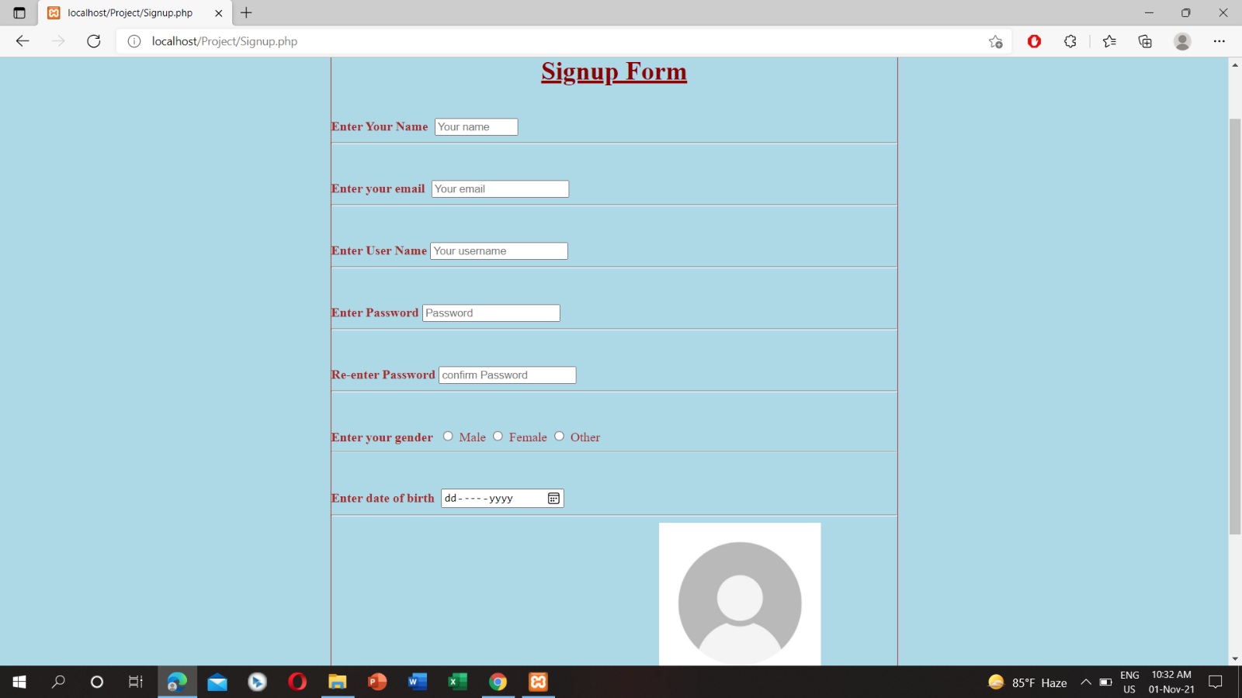

This is admin’s registration page. Admin can register using this form and the data will be stored in JSON file.

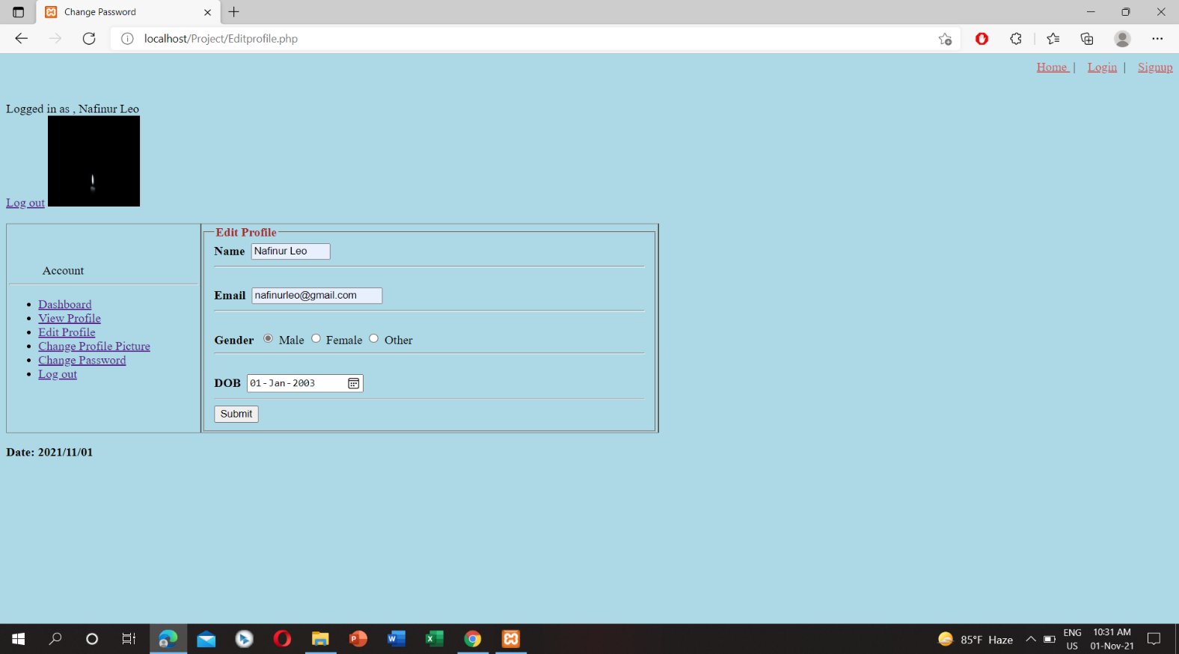

This is admin’s edit details page. Admin can edit their details from here.

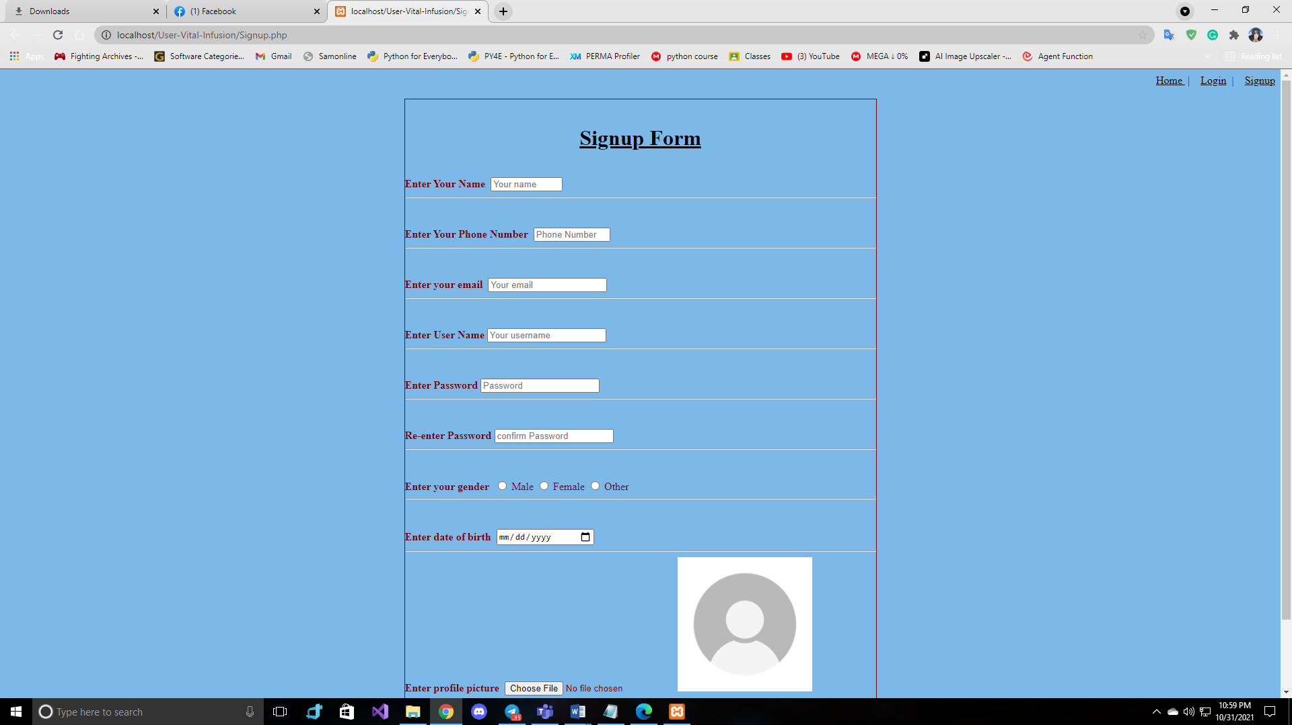

This is a part of user’s sign in form. User have to fill all the boxes and sign up. Thus, they can create an account. These data will be stored in JSON.

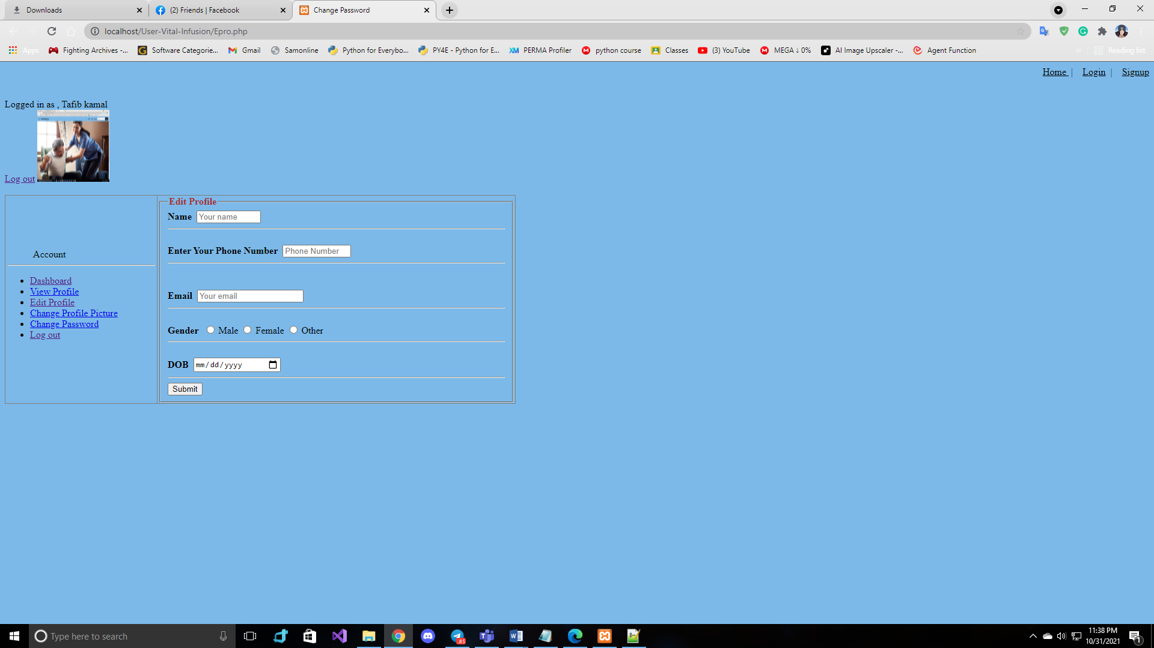

This is an edit profile section for the user. If, the user wants to update their data, they can update from here.

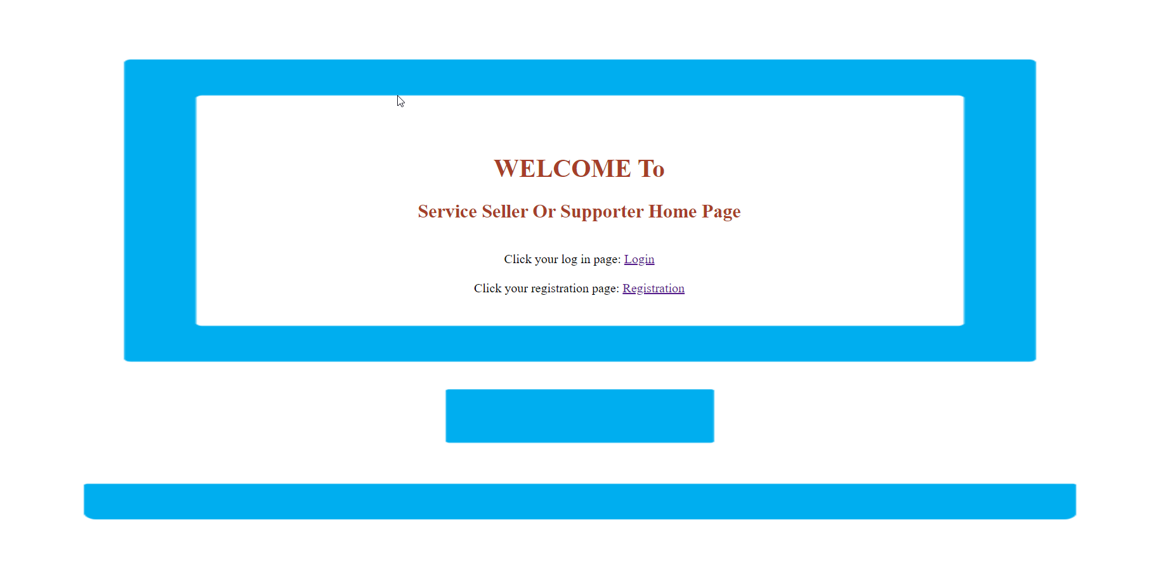

It is my Service Seller home page design. I use this system php class and function. By using php class and function printout Login and Registration link.

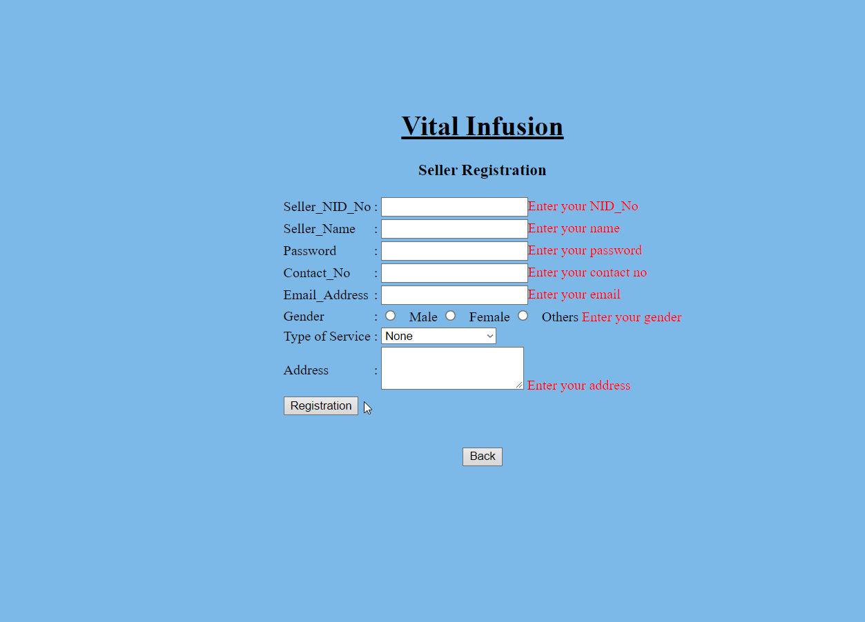

This is my Service Seller Registration page, in this page I used validation. By using validation when I click Registration button then screen shot showing empty field required message. All data from this page stored in json file.

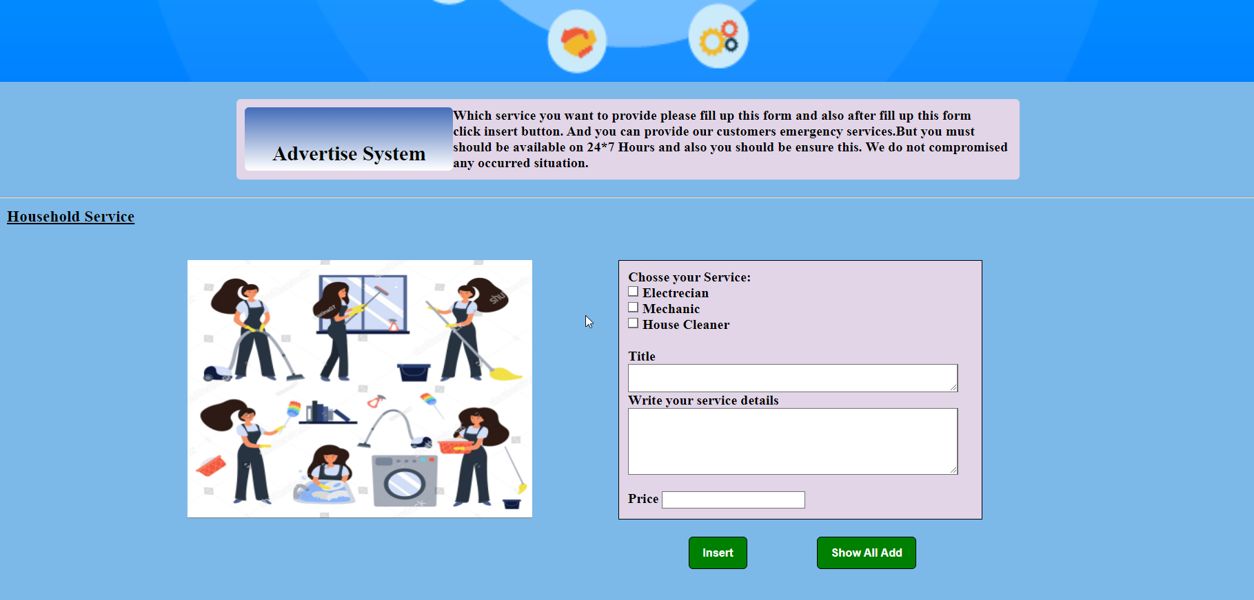

Besides Advertise System which paragraph is visible, it is visible by File read. In this page I also used Session.

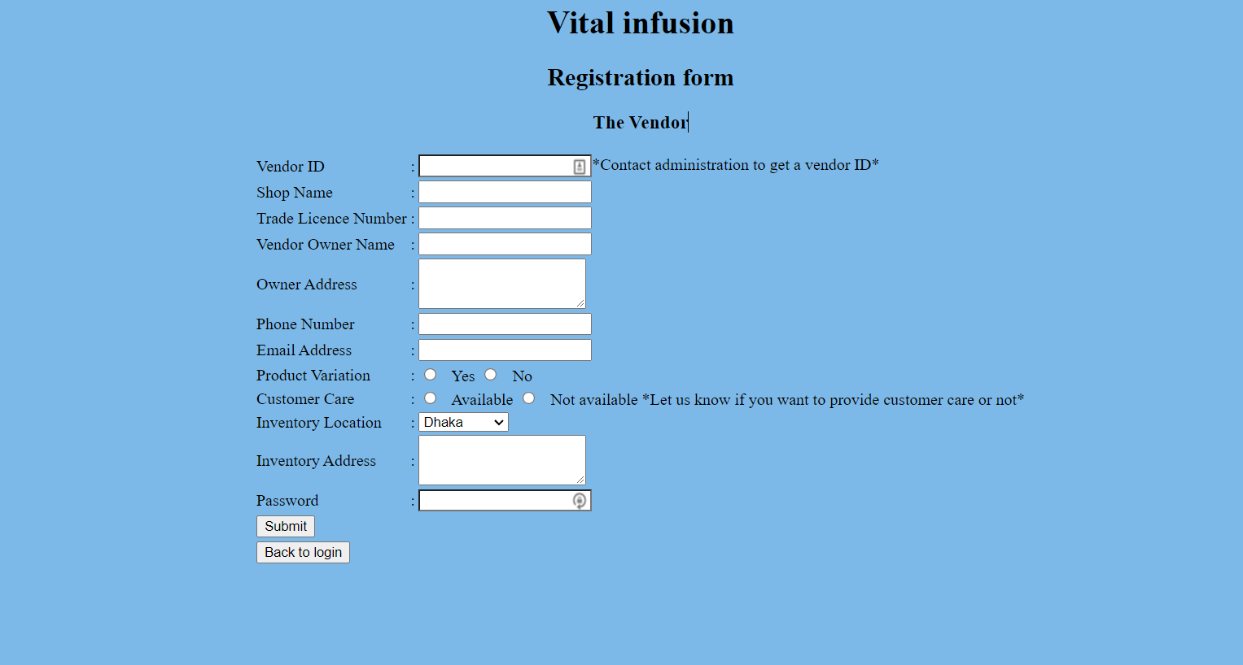

This is vendor registration page. There are varities of information needed to submit the whole form. Before registration, clients from vendor’s end must collect a vendor id from administration through email or phone.

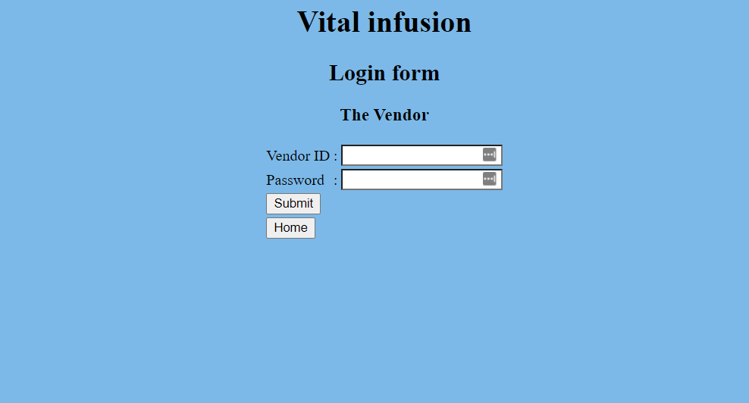

This is vendor login page. Here vendor must submit their id and password before they want to log in and change account information.

Impact of this Project:

Describe the increasing importance of your project on modern society and environment.

How will people be benefitted from your project?

This project will help people to find household and medical helps without much difficulties and they can search for services based on their convenience. There are some categories to search. It will make people’s life easier. Especially the working people who don’t have much time can easily get benefitted from our services. This project will have a positive impact on the society.

Limitations and Possible Future Improvements:

For now, we don’t have much medical services available. But in future we are planning to include adding ambulance service and online doctor consultancy. Another important feature to add is blood donation system.